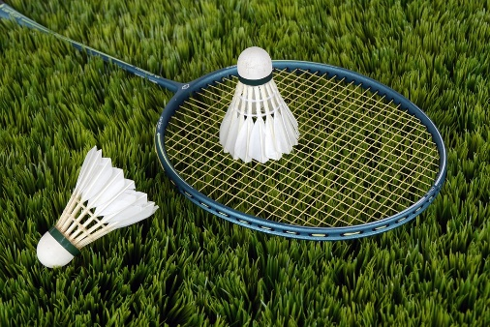
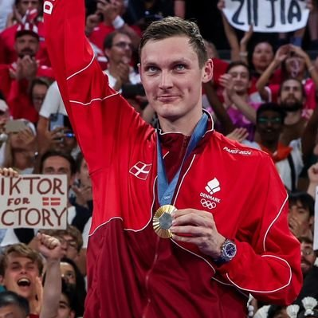

My favorite sport

B
adminton is a fast-paced racket sport where players hit a lightweight shuttlecock or birdie over a high net with racquets, aiming to land it in the opponents court, either as singles (one-on-one) or doubles (two-on-two). Its known for its quick rallies, requiring agility, speed, and precision, and played indoors competitively due to the shuttlecocks sensitivity to wind, though its also a popular outdoor recreational game. The game combines physical fitness with mental strategy, challenging players to develop reflexes, stamina, and court awareness

