My Favorite Sport.

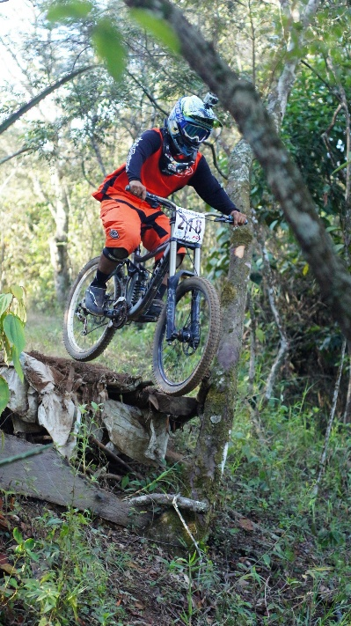

M
y favorite sport is cycling.
I like it because it’s fun and fun to play with friends.
You can even send mails to people by just using a bicycle or maybe even cycle to places like restaurants school etc.
Bicycle could be hard but after training for a few days it’s incredibly easy.
It’s good for motorcycle fans and makes you better at it.
Cycling is famous in France.

