My favorite sport

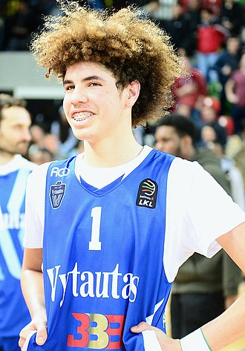

B
ask ball is a popular team sport played by two teams of five players on a rectangular court, with the primary goal of shooting the ball through the opponent's elevated hoop. The sport was invented in 1891 by Canadian physical education instructor James Naismith as an indoor winter activity at a YMCA training school in Massachusetts. Players move the ball by dribbling (bouncing it while running or walking) or passing it to a teammate; running with the ball without dribbling is a violation called traveling. Shots made from inside the designated arc are worth two points, while those from behind the arc are worth

