My Favorite Sport.

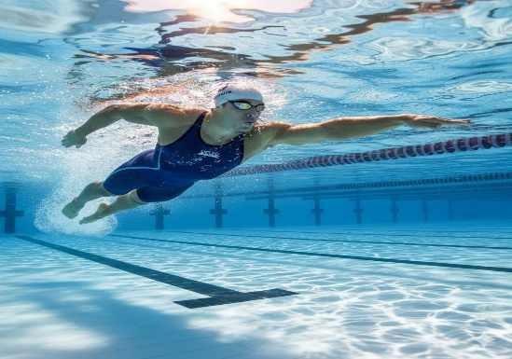

s
wimming is my favorite sport because it combines fitness, fun, and freedom in the water. Whether I'm gliding through the pool or diving into the deep end, swimming makes me feel weightless and energized. It’s a full-body workout that strengthens muscles, improves endurance, and boosts cardiovascular health. Beyond the physical benefits, swimming also helps clear my mind and reduce stress—there’s something calming about the rhythm of strokes and the sound of water. Whether I’m racing laps or just floating peacefully, swimming always leaves me refreshed and happy.
The first country to make swimming competitions was England. In 1837, the National Swimming Society was established, and competitions began to be held in artificial pools in London. This marked the beginning of competitive swimming as a recognized sport in England.

