My favorite sport

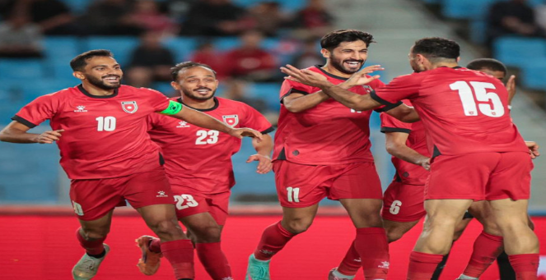

M
y favorite sport is football.because I feel good when I play it especially with my brother.
It is very fun and exiting but if I was a goalkeeper it would be frustrating because the whole team is
depending on you.the team that inspired me is Jordan international team because of how good they
play.i really like yazan al tamary because he is inspirational

