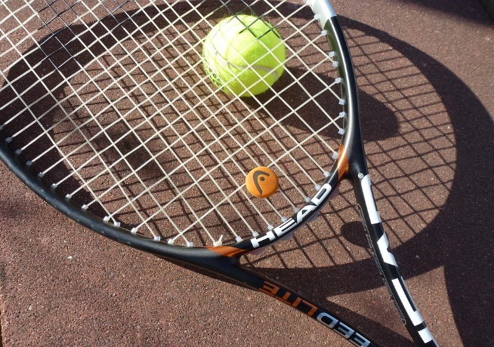

Tennis is fun because it's a brain game, a body workout, and a social sport. You can play it casually or competitively, indoors or outdoors, singles or doubles. You don't need a team or perfect weather—just a racquet and a willing partner. It's adaptable, accessible, and endlessly fun, whether you're 10 or 70.

