My Favorite Sport

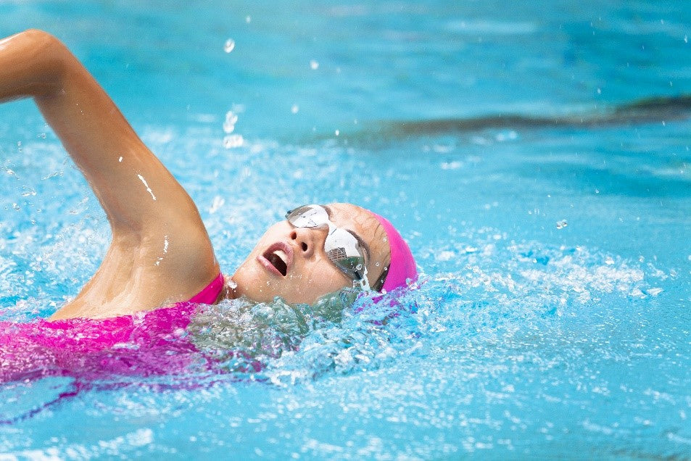

M
y favorite sport is swimming because it makes me feel relaxed and energized at the same time. When I’m in the water, everything around me becomes calm, and I can focus only on my breathing and movements. Swimming is great for the whole body — it strengthens the muscles, improves stamina, and keeps the heart healthy. I also love that it’s a sport for all seasons and all ages; anyone can enjoy it in Jordan. Whether I’m swimming for fun or trying to improve my speed, it always makes me feel happy and refreshed. It’s the perfect way for me to clear my mind and stay active.

