My Favorite sport

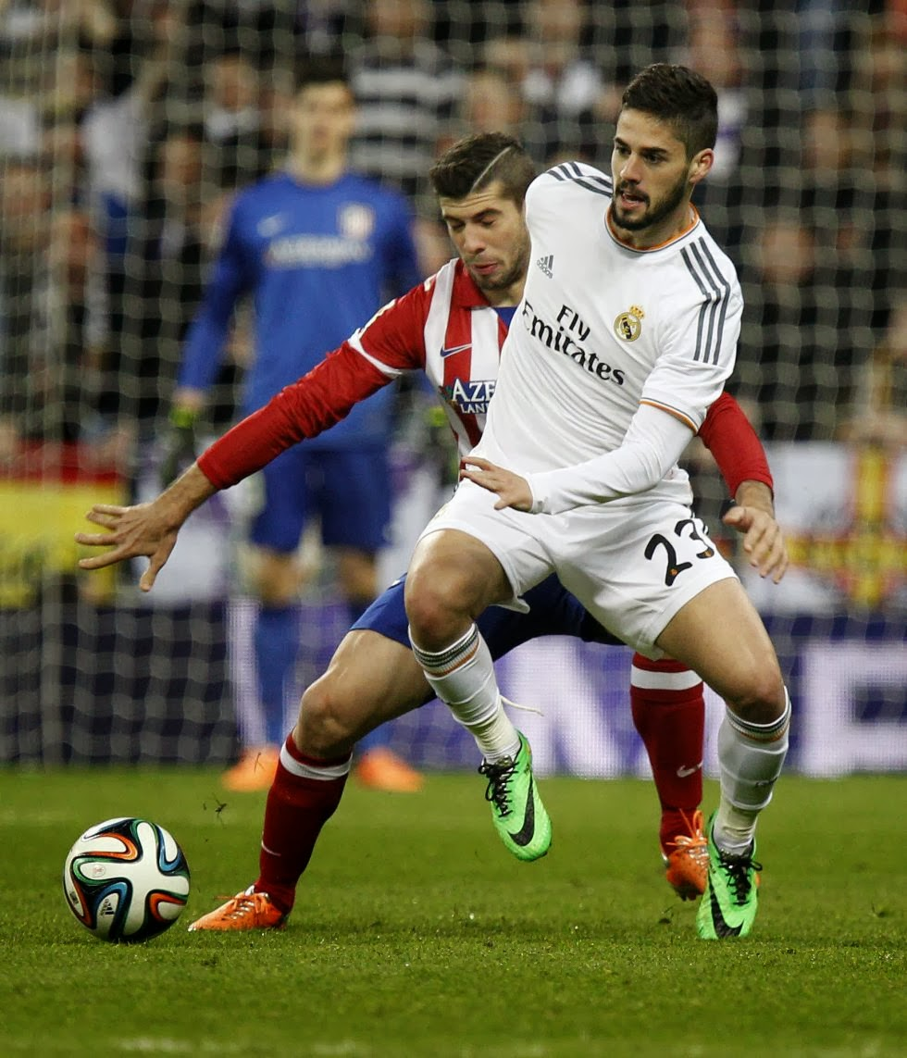
This Photo by Unknown Author is licensed under CC BY-SA-NC

I
ts challenging sport and its not always strength, it need to be fast and have agility, and the most popular country in football is Brazil.

