My Favorite Sport

+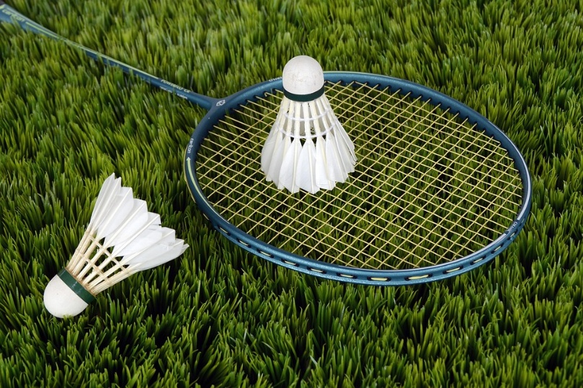

I

LOVE PLAYING BATMANTON, ITS MY FAVORITE SPORT BECAUSE ITS FUN AND EASY YOU CAN LEARN IT AT ANY TIME.
IM TRYING TO PRACTICE TO PLAY IT MORE SO I CAN BE A PROFECINAL BECAUSE IM NOT REALLY GOOD AT IT THE COUNTEY THAT IS FAMOUS IN BATMANTON IS UNITED STATES.

