Soccer

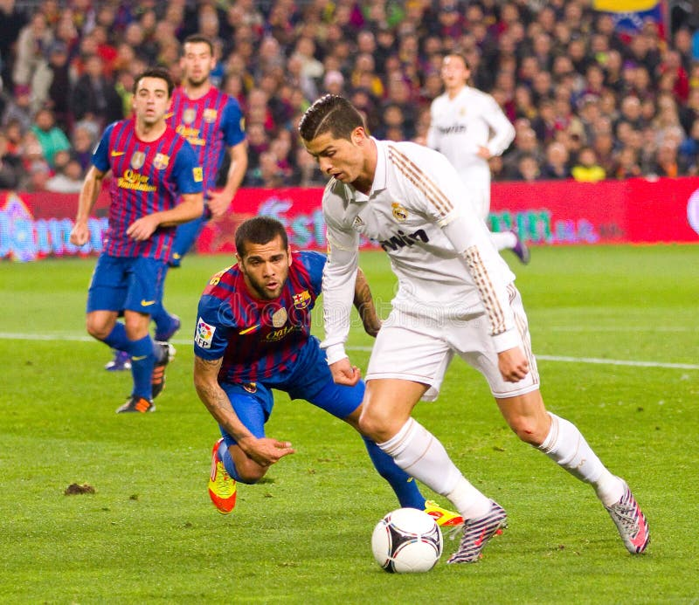

S
occer is my favorite sport because it is exciting and fun to watch and play. I enjoy cheering for teams from Spain and Brazil because they play with great skill. The game is played on a large field, and the goal is to score by kicking the ball into the other team’s net. I like practicing soccer with my friends because it helps me stay active and improves my teamwork. Many famous players inspire me and motivate me to get better.

