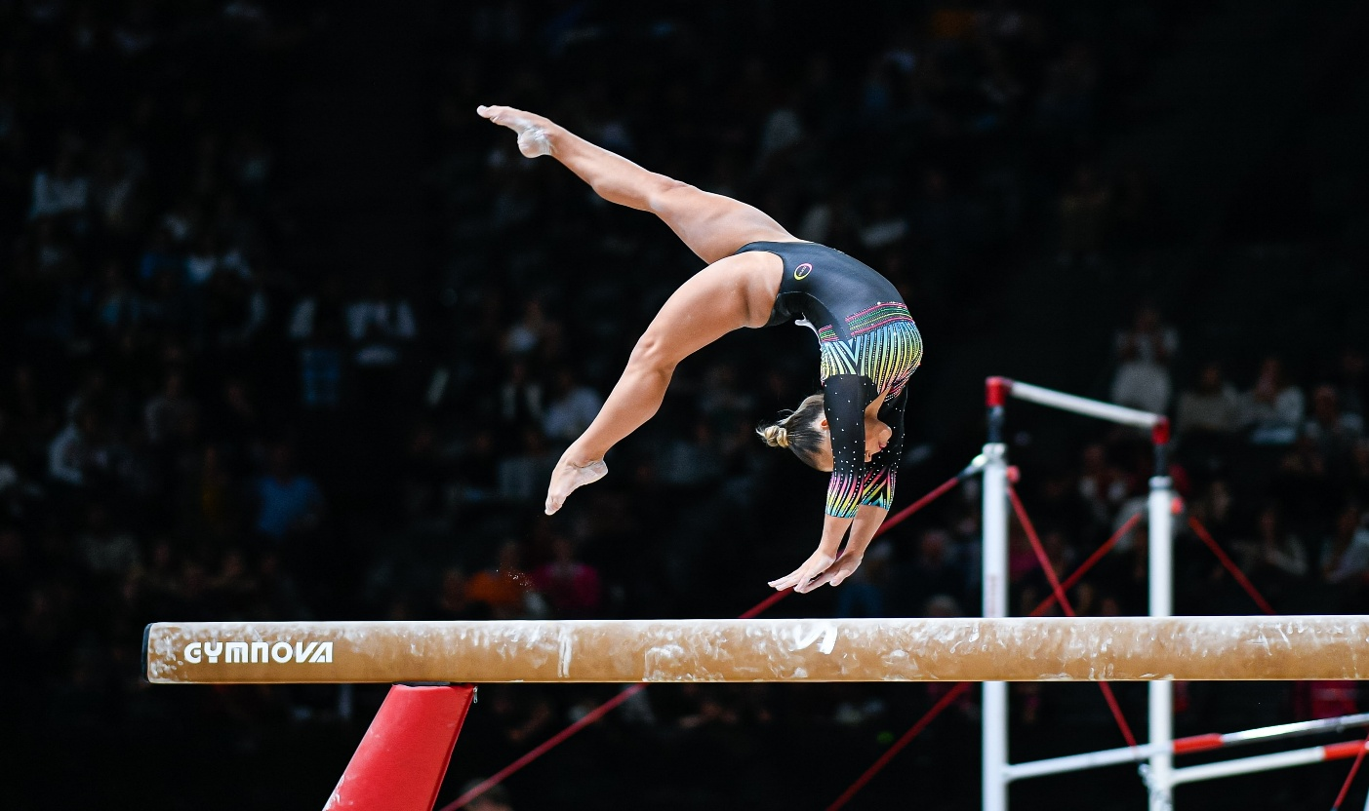
My favorite sport

M
y favorite sport is gymnastics because it’s a really fun sport and it have a lot of skills when you look at them you will want to learn and start this sport moreover I play gymnastic for two reasons the first one is that in your hole life you need to play a sport any kind of sport that will help your body to stay good and healthy until your last word but you should not stop even when you get big go walk like for an hour that will be really good or go to the gym like 3 days in a week that’s good, now the second reason is that I want to learn new skills that’s it bye-bye.

