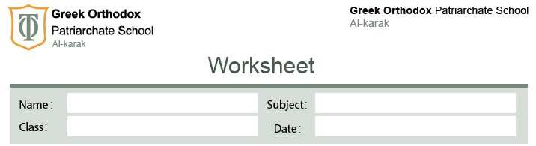
Watch the video carefully then answer the following questions:
- Write the names of the children in the video ,where they are from and their age :
Name | Country | Age
Emilia | Italy | 11
Mati | Poland | 10
Rafi | Saudi Arabia | 13

- What 3 things they would tell their friends about their country :
Mati | Emilia | Rafi
- Famous food is pieragi | 1-Famous food is pizza and pasta | 1-Very hot in the summer
- Winter is very cold | 2-Italian people love football | 2-most of the country is desert
- There is lakes and mountains | 3-rome is a capital city of Italy | - Riyadh is the capital city of Saudi Arabia

