Worksheet number ( 2 ) / Unit Three

Fit as a fiddle
/ Nov /2025
9th Grade

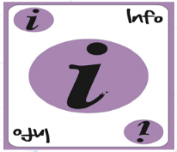

ASSIGNMENT 2

Answer the following questions then send them on LMS...

1. Do you think keeping fit is important for people of all ages?
Give me 2 reasons.
A.

B.

2. How can a person be healthy and fit?

A.
B.
C.
D.

3. What you do...

- if you feel stressed and need to relax _____________________________
____________________________________________________________
- if you feel ill or get hurt _______________________________________
____________________________________________________________

English Department.

