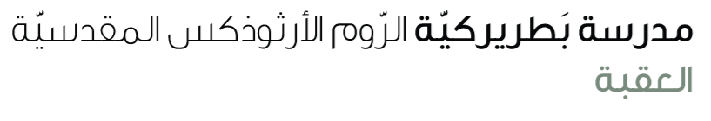
Name: Study guide 6th grade

Dear students kindly note that our first exam will be in unit 1(a good start ) on Wednesday 6th Oct.

Reading comprehension & vocabulary
W.B Page 16 ex 1 ,2,3
Page 16 study the paragraph (Good news for pangolins)) (vocabulary: scales / roll/ law/ trouble) Page 14 ex 1
S.B Page 18 ex 2 Page 28 ex 2

Grammar
If clause type 1 & 2
Type 1 | Type 2
If + s + V(1) … , S will + V(inf). | If + S + V(2) … , S + would + V(inf).
If + S + don’t/doesn’t + V(inf) …, S won’t +V(inf) | If + S + didn’t + V(inf) .. , S wouldn’t + V(inf) ..
If + S+ V1) …, Will + S + V(inf) … ? | If + S + V(2) …. , Would + S + V(nf)…?

S.B
page 19 ex 2
Page 21 ex 2
W.B
Page 15 ex 1,2
Page 17ex ,2,
Study the worksheet

