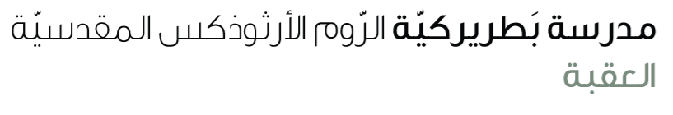
Name: Study guide 4th grade

Dear students kindly note that our first exam will be in unit 1(move to the music ) on Saturday 8th Nov.

Reading comprehension & vocabulary
/S.B page 20 ex 2, 3
W.B Page 16 ex 1 ,3
Study the Worksheet

Grammar
Past simple (regular verbs )
Verb to be( was / were )
adverb of manner

S.B page 19 ex,2,3 Page 21 ex 1,2 page 24 ex 2 page 28 ex 4, 5
W.B Page 17ex 1, 3 Page 22 ex 3 page 23 ex 4
Study the worksheet

